PHYSICAL THERAPY

Resources for Development

ChoosePT (American Physical Therapy Association resource)
https://www.choosept.com/search/results?q=pediatrics&realmName=HTTP&wt=json&rows=10&start=0

American Academy of Pediatrics: Physical Developmental Delay Tool
https://www.healthychildren.org/english/motordelay/pages/default.aspx

Tummy Time Tips
https://www.choosept.com/resources/detail/tummy-time-tools

Autism:
https://www.choosept.com/symptomsconditionsdetail/physical-therapy-guide-to-autism-spectrum-disorder
https://www.choosept.com/radio/detail/austims-spectrum-disorder-collaborative-care-varie

Cerebral Palsy:
https://www.choosept.com/symptomsconditionsdetail/physical-therapy-guide-to-cerebral-palsy-2

Down Syndrome:
https://www.choosept.com/symptomsconditionsdetail/physical-therapy-guide-to-down-syndrome-2

Muscular Dystrophies:
https://www.choosept.com/symptomsconditionsdetail/physical-therapy-guide-to-muscular-dystrophies-in-children

Prader Willi Syndrome:
https://www.choosept.com/symptomsconditionsdetail/physical-therapy-guide-to-prader-willi-syndrome

Prematurity:
https://www.choosept.com/symptomsconditionsdetail/physical-therapy-guide-to-infant-prematurity

Spina Bifida:
https://www.choosept.com/symptomsconditionsdetail/physical-therapy-guide-to-spina-bifida

Movement videos:

Cosmic Kids Yoga
https://www.youtube.com/user/CosmicKidsYoga

Go Noodle
https://www.gonoodle.com/

Go with Yo Yo
https://www.youtube.com/channel/UCg66zBWz7bQOXAw31MdtPCQ

Koo Koo Kangaroo
https://www.youtube.com/KooKooKangaRoo

Home Exercises Ages 6-10 (PT guided)
https://www.choosept.com/patientresources/videolibrary/detail/home-exercises-from-physical-therapist-kids-aged-6

Inspirational:

Kid President
https://www.youtube.com/playlist?list=PLzvRx_johoA-YabI6FWcU-jL6nKA1Um-t&feature=plcp

20 Things we Should Say More Often
https://www.youtube.com/watch?v=m5yCOSHeYn4&list=PLzvRx_johoA-YabI6FWcU-jL6nKA1Um-t&index=72

Breathing and Mindfulness:
https://www.youtube.com/watch?v=RiMb2Bw4Ae8
https://www.youtube.com/watch?v=iEEJT9cYsm0&t=378s

Preview YouTube video Kid President's 20 Things We Should Say More Often
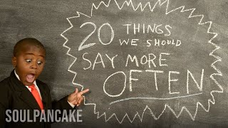
Kiesident's 20 Things We Should Say More Often
Preview YouTube video Belly Breathing: Mindfulness for Children
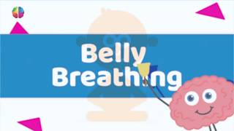
Belly Breathing: Mindfulness for Children
Preview YouTube video Kids Mindfulness: Calm Compilation
dfulness: Calm Compilation

